# Detailed Simulation Results

In this section, all the necessary realistic simulation results are shown with the selected components. The following Figure X shows the complete circuit diagram. One can realize that there are some minor differences between circuit diagram in the previous report and the following one. Firstly, this circuit diagram contains leakage current analysis and simulations showed that the previous snubber part is not enough to compensate this leakage current. Therefore, snubber part was updated. On the other hand, after thermal analyses, cooling the output diode is not an easy and cheap work. Therefore, five parallel diodes were connected at the output to decrease the current passing through one of them. This also allow us to build circuit without any cooling operation. The detailed thermal analyses are shown in “Thermal Calculations” section. Finally, this new circuit also includes load regulation analysis. To observe the reaction of the circuit in the case of load regulation, small circuit placing right upper corner of the following diagram were used.

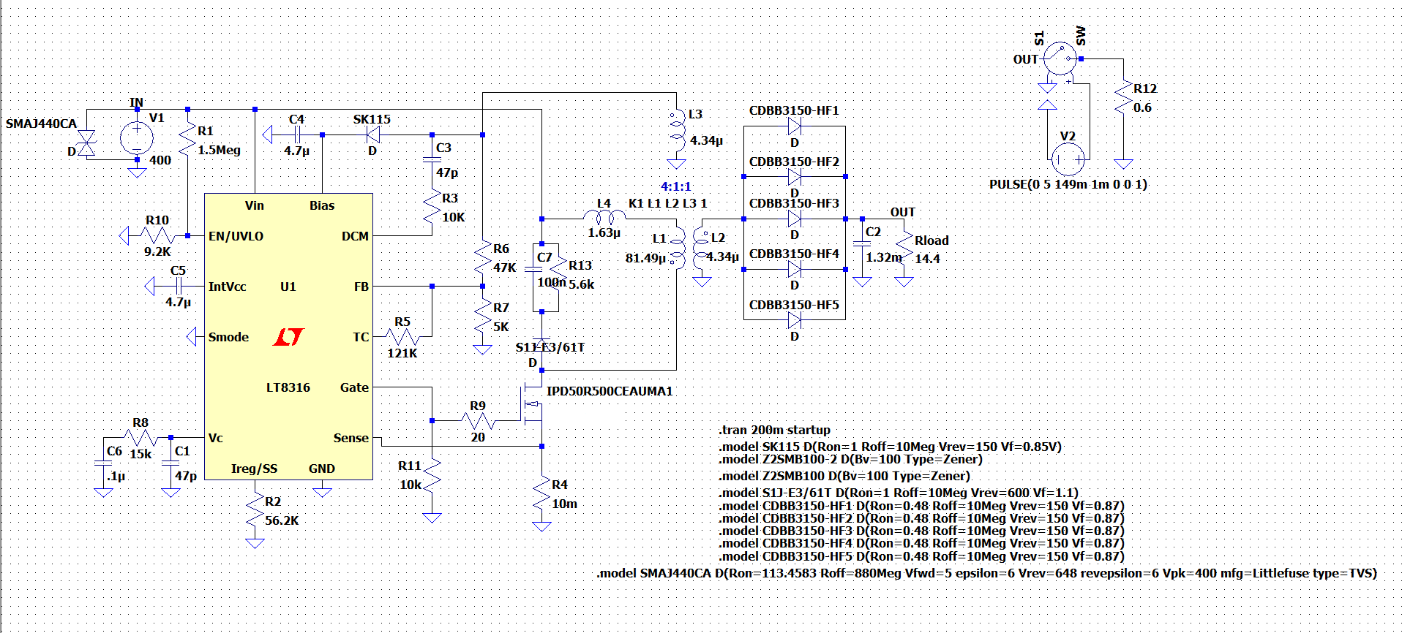

Figure Circuit Diagram of the Design

As the project specs indicates that the input voltage can vary between 220V and 400V. The input voltage changing with respect to time is shown in Figure Z. Also, Figure X and Y show that the performance of the output voltage and the output voltage ripple, respectively.

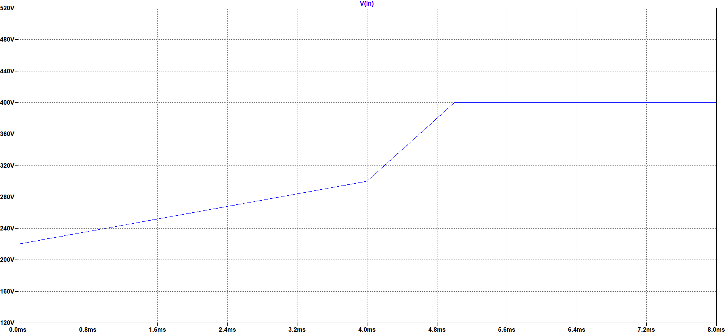

Figure Varying Input Voltage

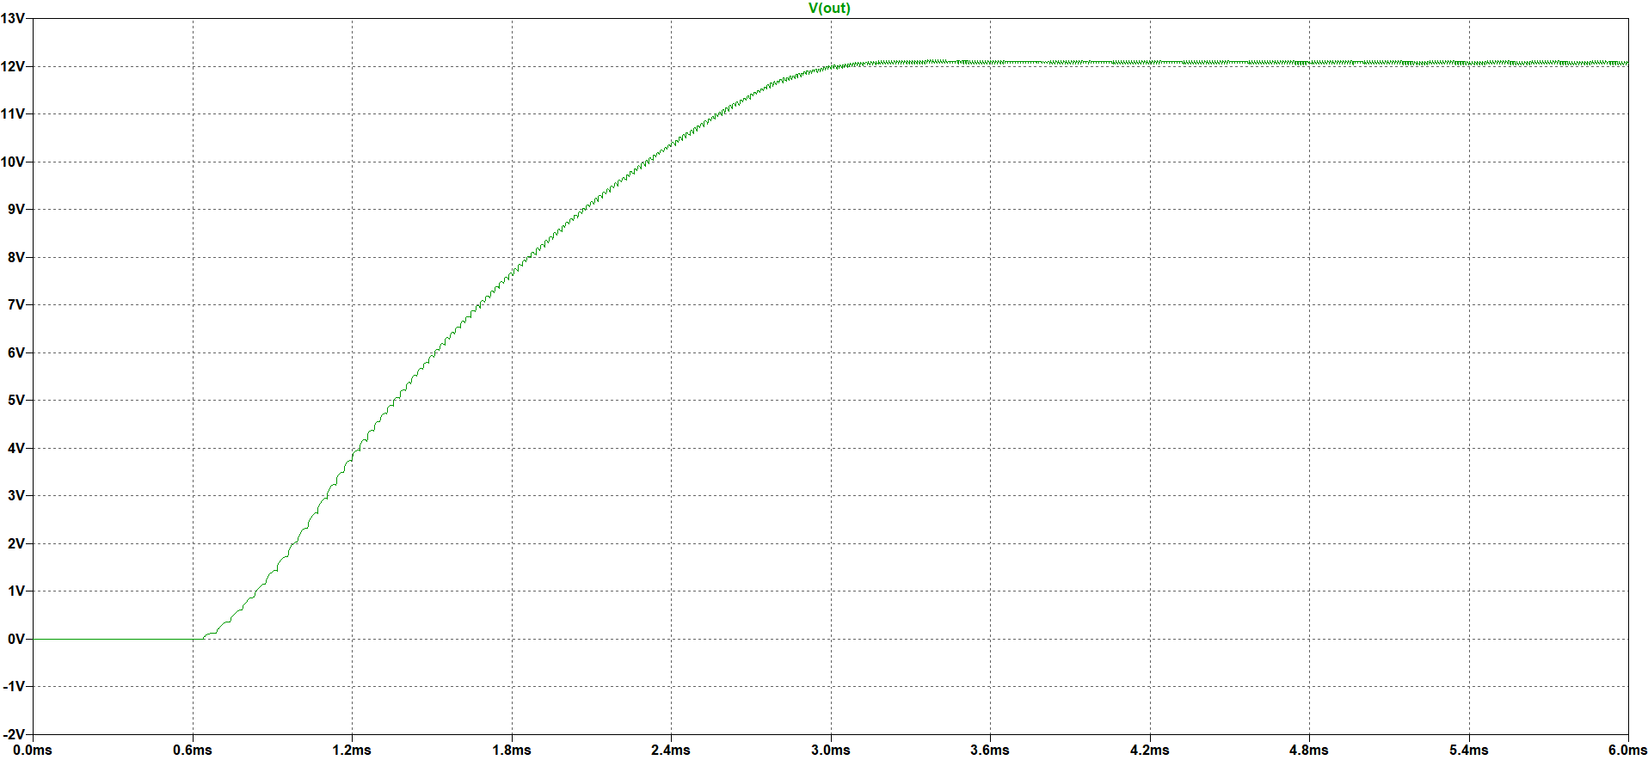

Figure Output Voltage Performance for Varying Input Voltage

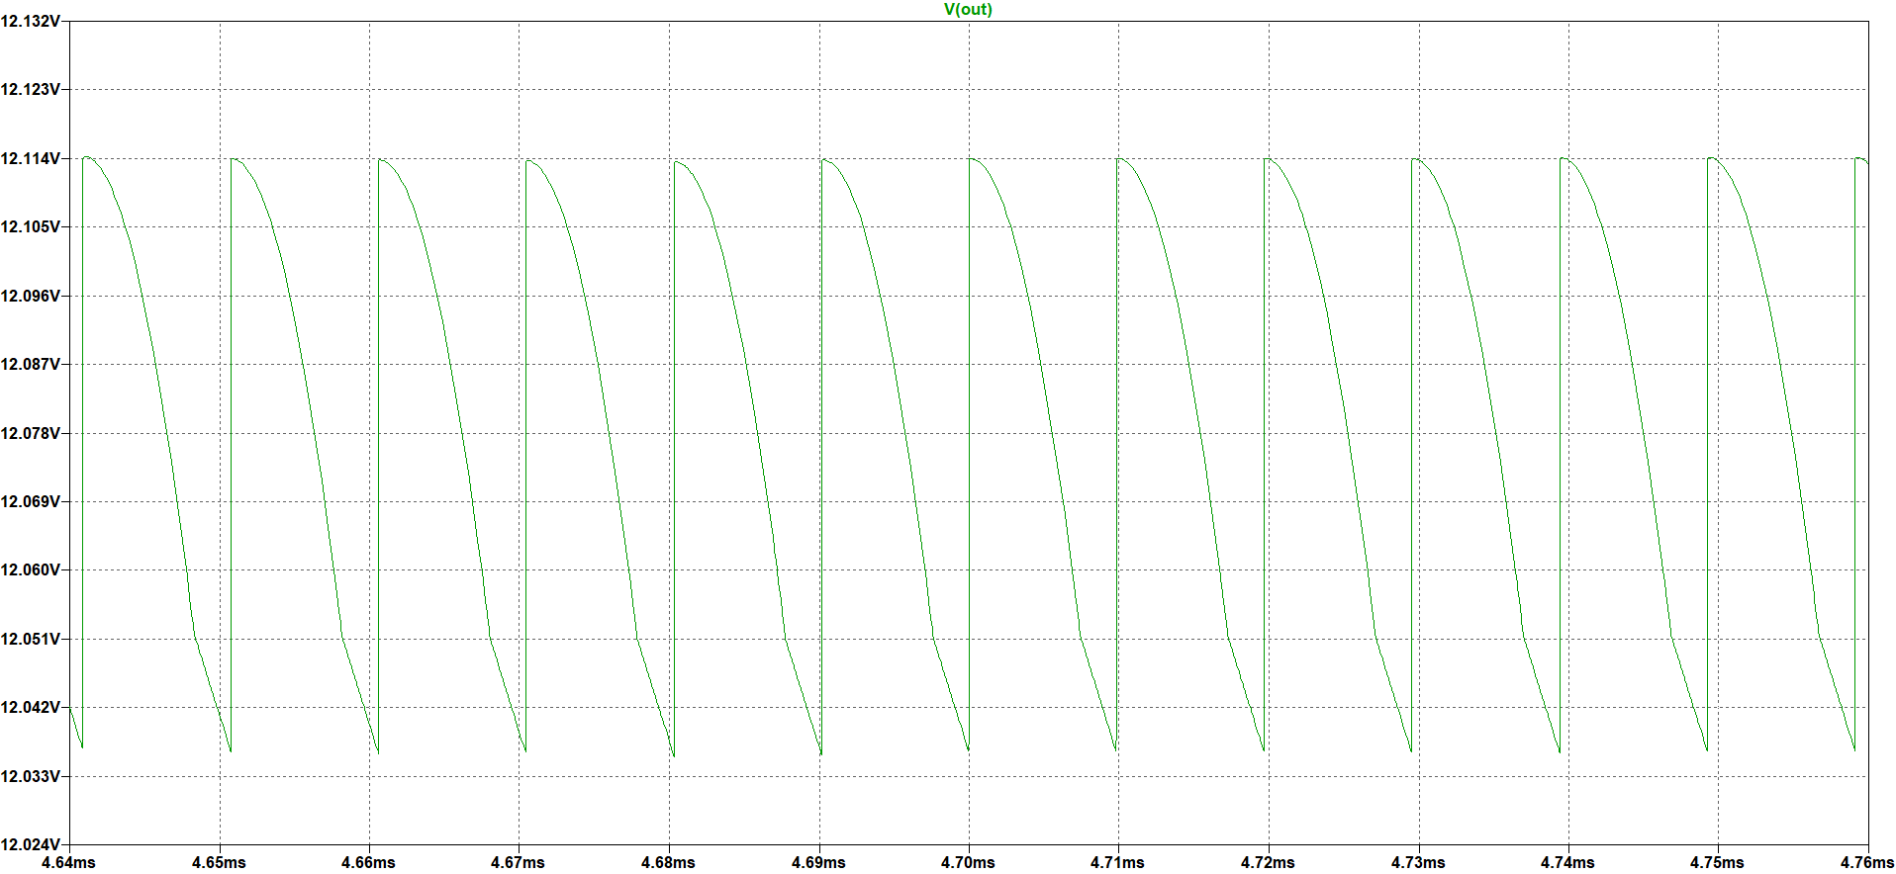

Figure Output Voltage Ripple for Varying Input Voltage

As can be seen in the above figures, the output voltage almost is not affected by the varying input voltage. It can give 12V with a small ripple which is in the specified ripple margin.

The following Figure X shows the output voltage performance. As can be seen in that figure, the controller has a soft start property and the output voltage reaches 12V around 145ms. Since the output voltage reaches 12V almost same time even for the extreme cases,

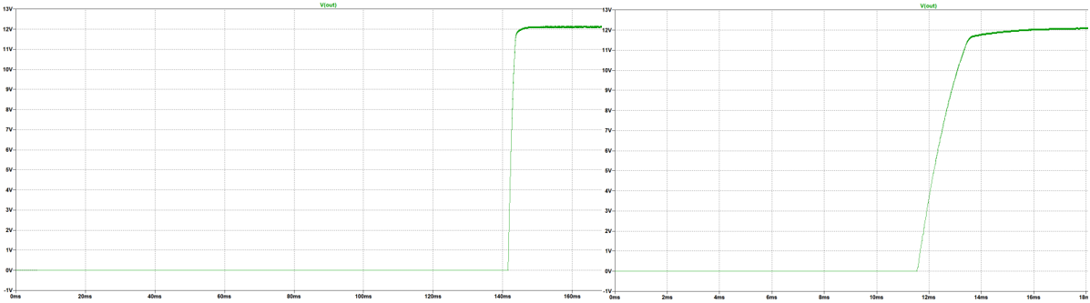

Figure Output Voltage Waveform for 220V (left) and 400V (right) Input Voltage

The following Figure X shows the output voltage ripple both 220V and 400V input values.

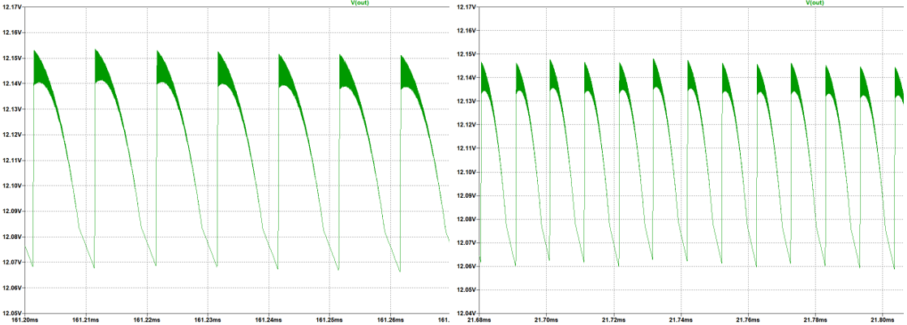

Figure Output Voltage Waveform for 220V (left) and 400V(right) Input Voltage

The following Figure X and Y show the performance of the design in the case of load regulation.

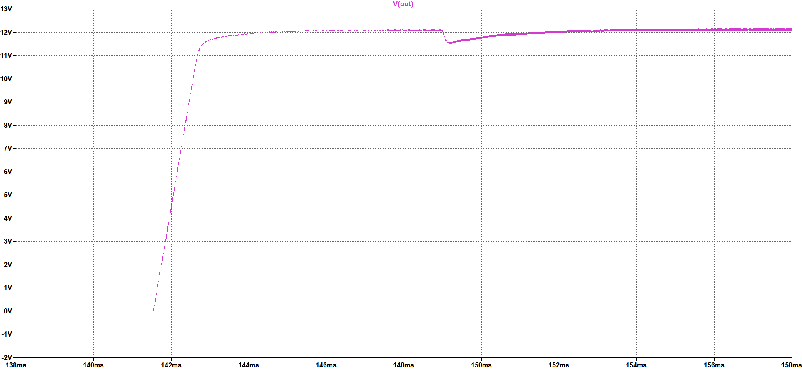

Figure Load Regulation Performance of the Design

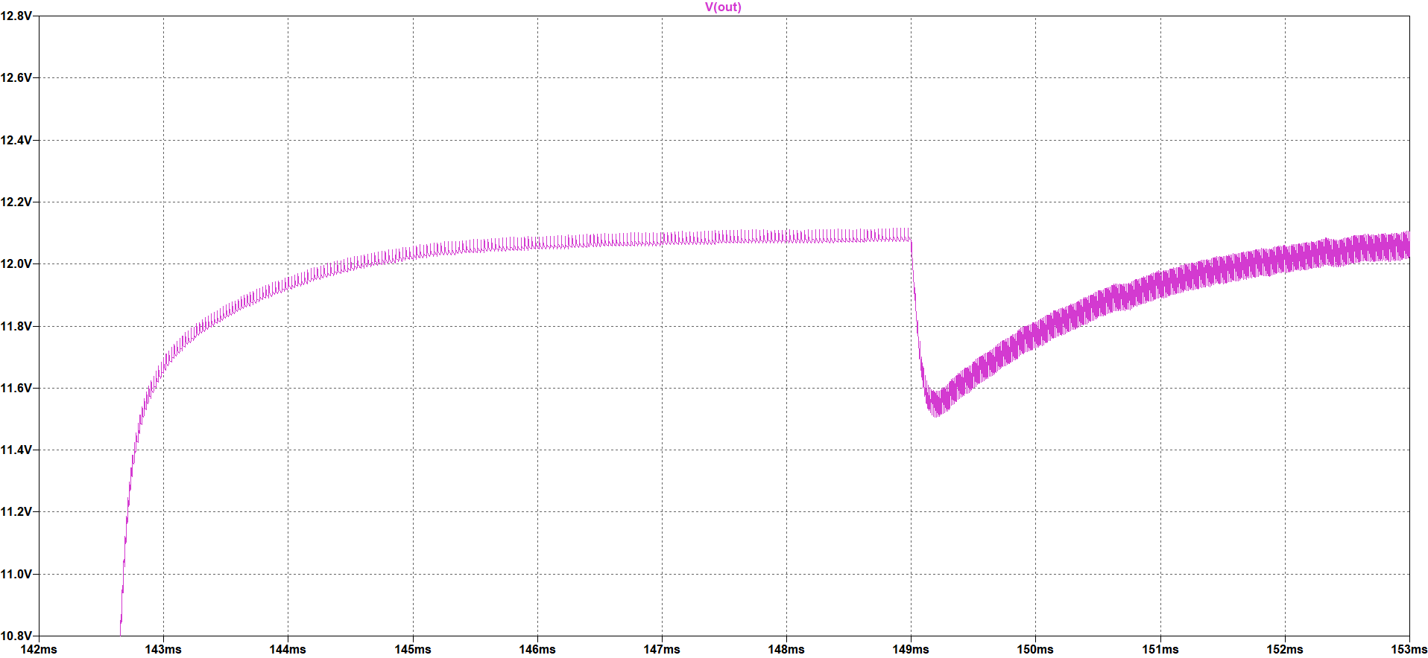

Figure Output Voltage Drop against Load Regulation

It can be realized from the above figures, the voltage the for this analysis is around 0.35V and this value is 3% of the output voltage. Hence, the project criterion is satisfied.

The current passing through the output capacitor which can be seen in the following Figure Y is also important for the capacitor selection.

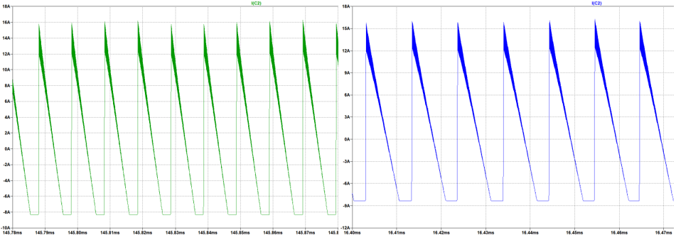

Figure Output Capacitor Current Waveform for 200V (left) and 400V (right) Input Voltage

As can be seen in the above figures, the current ripple on this capacitor is almost 23A. Therefore, the selected capacitor for the output side should filter this ripple. Furthermore, to obey the 4% voltage ripple criterion the ESR value of the selected capacitor must be very small.

The following Figure X and Y shows waveforms of one of the output diode current and the voltage on the diodes, respectively.

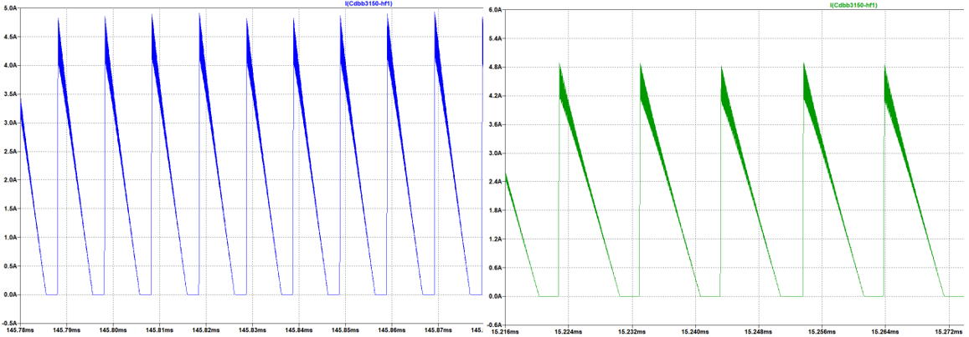

Figure Output Diode Current Waveform for 200V (left) and 400V (right) Input Voltage

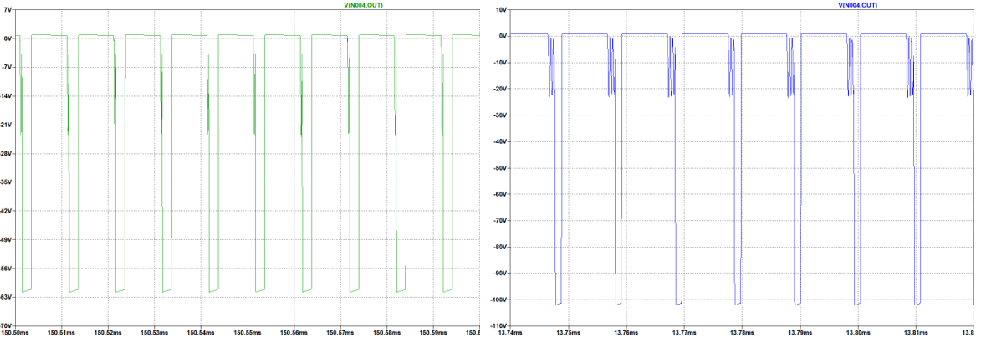

Figure Output Diode Voltage Waveform for 220V (left) and 400V (right) Input Voltage

As can be seen in the above figures, one of the diode currents is almost same for different input voltages and around 4.8A, and the total current on all the diodes is around 22A; however, the reverse voltages on these output diodes are not same. When the input voltage is 400V, the diode can withstand almost 110V. These values are important for suitable output diode selection.

The following Figure X and Y shows the MOSFET gate voltage and current waveforms, respectively.

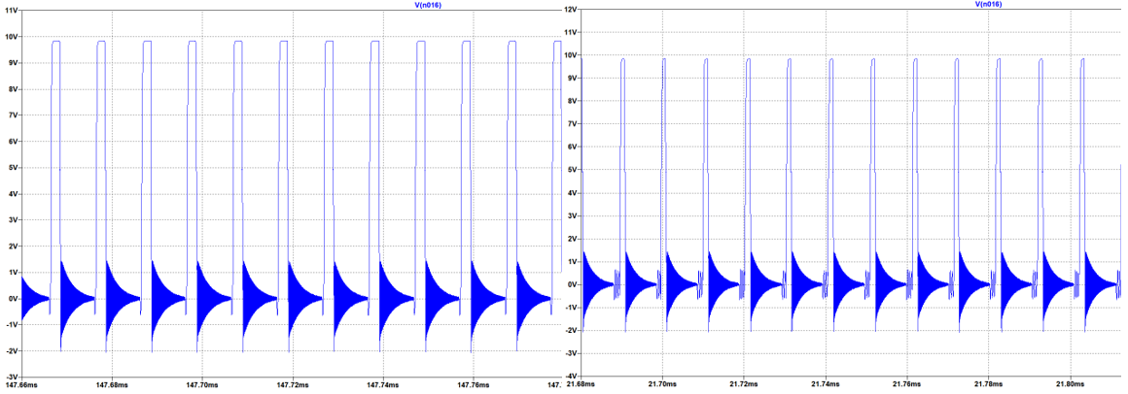

Figure MOSFET Gate Voltage Waveform for 220V (left) and 400V (right) Input Voltage

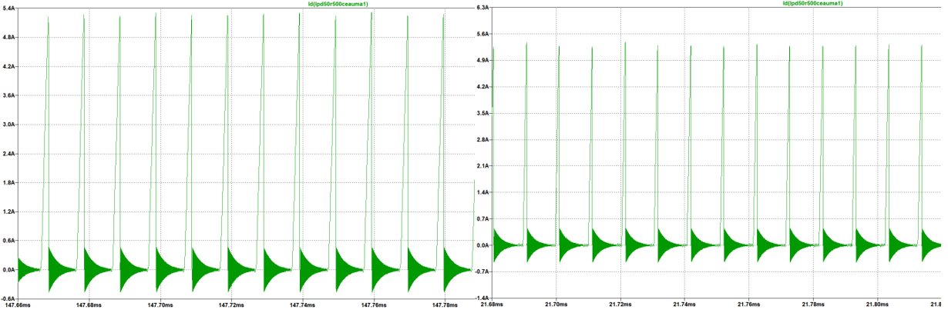

Figure MOSFET Current Waveform for 200V (left)and 400V (right) Input Voltage

As can be seen in the above figures, the gate voltage of the MOSFET is almost same for both cases and around 10V. Moreover, the current waveforms are also similar, and it is around 5.1A. These values are important for suitable MOSFET selection.

In the following Figure X, reverse voltage waveforms of snubber diode can be seen.

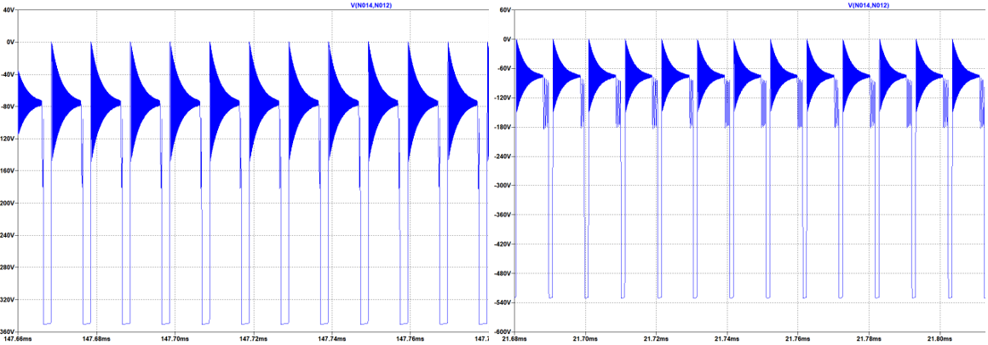

Figure Snubber Diode Reverse Voltage Waveform for 200V (left) and 400V (right) Input Voltage

As can be seen in the above figure, the snubber diode reverse voltage is relatively high. That’s why the selected diode can withstand 600V reverse voltage.

The following Figure X shows the power loss on the snubber resistance in Watt is shown for both 220V and 400V input voltage values.

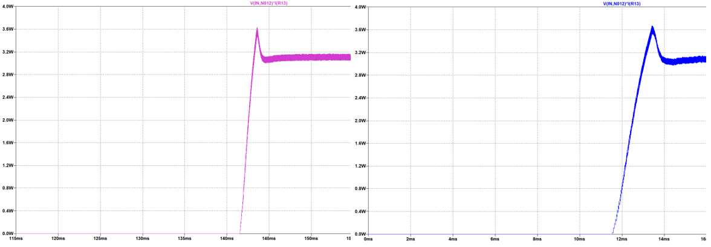

Figure Power Losses on the Snubber Resistance for 220V (left) and 400V (right) Input Voltage